**B1-SET B**

**Part A**

1. **Which of the following will not be accepted by the following DFA?**

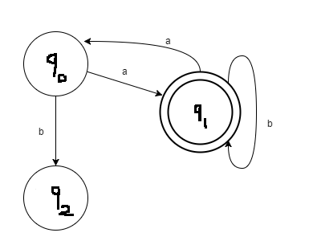

**a) ababaaba** b) abbbaa c) abbbaabb              d) abbaabbaa

2. The symbolic programming paradigm which aids in finding the roots of the equations___

1. **Sym.solve** b) sym.solveset c) sym.diff d) sym.factors

3. ________ function is used to convert any arbitrary expression such that it can be used as a SymPy expression.

A.evalf() **B. sympify()** c) lambdify() d) limit

1. What is wrong in the given definition? Def: ({q0, q1, q2}, {0,1}, δ, q3, {q3})

a) The definition does not satisfy 5 Tuple definition of NFA

b) There are no transition definition

**c) Initial and Final states do not belong to the Graph (set of states)**

d) Initial and final states can’t be same

1. Automata can be defined by using

a) 4 tuples b) 5 tuples c) 3 tuples d) 2 tuples

1. What is a python library that can be used to send and receive data over HTTP?

a) http **b) urllib** c) port d) header

1. Which method of the socket module allows you to send data to a given address?
2. socket.sendto(address, data)
3. socket.address()
4. **socket.sendto(data, address)**
5. socket.data
6. Which method of the socket module allows you to associate a host and a port with a specific socket?
7. The socket.sendto(PORT) method
8. **The bind(IP,PORT) method**
9. The bind(PORT,IP) method
10. The socket.accept(PORT) method
11. Which method of the socket module allows a server socket to accept requests from a client socket from another host?
12. **socket.accept()**
13. socket.sendto(address)
14. socket.acceptsocket
15. accept.socket()
16. The set of all strings over the alphabet S = {a, b} (including e) is denoted by
17. **(a + b)\***
18. (a + b)+
19. a+b+
20. a*b*